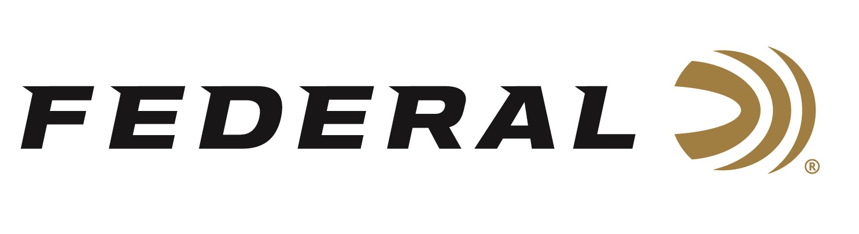

FOR IMMEDIATE RELEASE

Team Federal’s Kruse Wins Event Title at Browning Briley

ANOKA, Minnesota – April 14, 2026 – Federal Ammunition’s newest team member Cory Kruse is already making an impact on the NSCA circuit. The world title holder and professional coach joined Team Federal early in 2026 and already has a signature event win at the Browning Briley. The NSCA-sanctioned event drew more than 600 of the best sporting clay shooters to the Greater Houston Sports Club. The tournament ran April 7-11, 2026.

In a deep field of competitors, Kruse captured the Super Sporting event, besting a field of more than 370 shooters. “It’s great to see Cory returning to his high-level competitive form,” said Federal’s Vice President of Marketing Jason Nash. “He has the experience and competitive drive to push the best on the NSCA circuit, and I’m sure many are watching his results,” said Nash. Besides the Super Sporting win, Kruse also placed in several other events, including FITASC, the Federal Prelim Sporting event, and 5-Stand competitions.

Jonathan Prince also turned in some top performances in Houston. Prince, a college student, finished second overall in the Federal Ammunition Prelim Sporting event and third overall in the FITASC competition.

Federal Ammunition products, including the new Master Class, are available at dealers nationwide and online. This competition-level sporting clay load features a customized Podium wad that extracts peak performance from utilizing Federal’s straight-wall hull, reliable primers, high-antimony lead shot, and select propellant. For more information on Master Class and all Federal products, visit www.federalpremium.com.

Federal Ammunition products are available at dealers nationwide and online. For more information on all Federal products and to sign up to receive notifications about new product availability, rebate promotions, and other brand news via email, visit www.federalpremium.com.

Press Release Contact: JJ Reich
Senior Manager – Press Relations
E-mail: media@tkghunt.com

About Federal Ammunition
Federal, headquartered in Anoka, MN, is an ammunition brand of The Kinetic Group, owned by CSG, a globally diversified industrial group based in Prague, Czech Republic. Since 1922, Federal has been a leader in ammunition innovation, delivering high-quality sporting and hunting products to shooters worldwide. With a commitment to conservation and the outdoor community, Federal continues to manufacture industry-leading ammunition that enhances the shooting experience while supporting outdoor traditions.

